VWR Sterile Coverall CAT III Type 5/6
60g SMS, with Hood, Elastic Wrist, Ankle and Back, Zip down Front,
Zipper Bi Directional, Thumb Loop at Sleeves, Bound Seams, aseptic donning design

Intended use

Sterile cleanroom production or research

General Sepcification

Item | Test method | Standard
Material | - | 60g SMS
Color | - | White
Zipper | - | Nylon
Elastic | - | Thumb loop : latex free  Rest : latex
BFE (Bacterial Filtraction Efficiency) | ASTM F2101 | >90.5%
Particle Shedding | IEST-RP-CC003.3  (≥0.5μm/cu. ft.) | 409  Level I
Sterilization | ISO11137 | SAL10⁻⁶
Surface resistivity (Ω) | EN1149-1:2008 | <2.5*10⁹

Material Specifications

1. 60gsm SMS
Item |  | Test method | average value standard
 |  | Test method | average value | tolerance for average value
Weight(g/m2) |  | GB/T4669-1995 | 60.00 | +/-3
Thickness(mm) |  | ASTM D1777 | 0.184 | +/- 0.02
Break Tensile propertities(N) | MD | ASTM D5034 | >60
Break Tensile propertities(N) | CD | ASTM D5034 | >35
Elongation rate(%) | MD | ASTM D5034 | >30
Elongation rate(%) | CD | ASTM D5034 | >30
Tear prosperities | MD | ISO9073-4 | >30
Tear prosperities | CD | ISO9073-4 | >30
Hydrostatic press test  (mmH₂O) |  | AATCC127 | >450
Air permeability test  (mm/s) |  | ISO9073-15 | >200
Surface resistivity (Ω) |  | EN1149-1:2008 | <2.5*10⁹

Dimension Specification
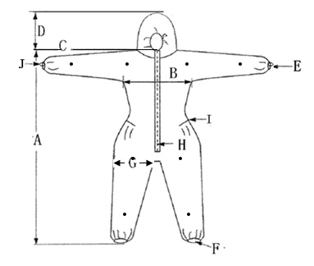

EU Cat. No. | SIZE | A | B | C | D | E | F | G | H | I | J
113-7881 | S | 166 | 57 | 85 | 28 | 8/18 | 12/24 | 29 | 72 | 35 | 15
113-7882 | M | 169 | 60 | 86 | 28 | 8/18 | 12/24 | 32 | 73 | 35 | 15
113-7883 | L | 176 | 63 | 90 | 28 | 8/18 | 12/24 | 35 | 82 | 40 | 15
113-7884 | XL | 178 | 66 | 92 | 28 | 9/20 | 13/26 | 36 | 82 | 40 | 15
113-7885 | XXL | 186 | 74 | 98 | 28 | 9/20 | 13/26 | 39 | 82 | 45 | 15
113-7886 | XXXL | 192 | 79 | 99 | 28 | 9/20 | 13/26 | 43 | 85 | 45 | 15
Tolerance |  | ±2 | ±2 | ±2 | ±2 | ±1/±2 | ±1/±2 | ±1 | ±2 | ±3 | ±1

Packaging Specification

Package/Quantity | 1pcs/pe bag/pe bag, 20pcs/case liner/case
Best storage Conditions | 0- 50°C
Best storage Conditions | 45% - 65% humidity
Best storage Conditions | dry
Shell Life | 5 years
Country of Origin | China

Product Compliance:

ISO 13485:2003 Medical device-Quality management system-requirements for regulatory
EN 13034:2005+A1:2009 Protective clothing against liquid chemicals – Performance requirements for chemical protective clothing offering limited protective performance against liquid chemicals
EN ISO 13982-1:2004+A1:2010 Protective clothing for use against solid particulates-Part1: Performance requirements for chemical protective clothing providing protection to the full body against airborne solid particulates
EN1149-5:2008: Protective clothing - Electrostatic properties - Part 5: Material performance and design requirements

Disclaimer: VWR wants to state that this declaration will not discharge the user from his obligation to ensure the product is suitable for the intended use. - If there is any doubt ask us.

Date of issue: Dec 2021

