Unable to read? View web vision.
Thank you for your continued interest in our PEG products. As the year is approaching the end, Creative PEGWorks offers exciting sale promotions on selected PEG derivatives including:
Linear monofunctional mPEG
Amphiphilic PEG surfactants
Click chemistry PEG derivatives
Thiol PEGylation reagents
15% discounts are offered for all PEG products of these four catagories. If you purchase multiple items, there are additional discounts. This sale promotion ends on December 12 2014.
View our the complete of our PEG products
See who published papers with our polymer products.
Have a great holiday season!
Team Creative PEGWorks
PEG Products
mPEG-Amine
See all PEG Products products

PEGylation Reagents
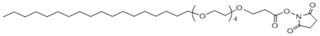
C18-PEG4-NHS
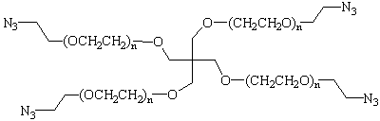
4-Arm PEG-Azide
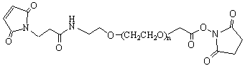
MAL-PEG-SCM
See all PEGylation Reagents products
Creative PEGWorks
P.O. Box 5853
Winston Salem, NC 27113
USA

